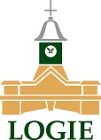

Logie Steading News
Open every day from 10 a.m.
Mini-market this Saturday 21st May
Jubilee celebrations and more ...
Only ten minutes from Forres ........ A place to take your time

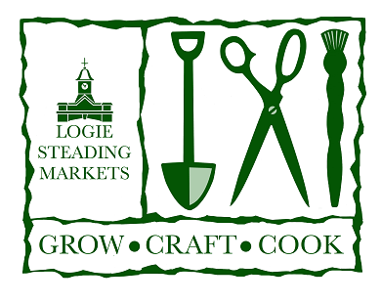

What's On at Logie Steading
This month's mini-market is on May 21st
A hand picked collection of fabulous makers and growers will be in the courtyard and round by the Farm Shop on the third Saturday of the month.
Featured in the May Mini Market are
Little Robin knits
Caitylou Creations
Old barn leather
Claire Dansons Art
Mary Jean
Coast candles
Lorien glass
Weaving the Love
Lori Jayne craft creations
Jackie Hichens Art
Fodderty Woodturning
Keltic Kitchen
The Plant Whisperer
Love Mushrooms
Time to head to Logie Steading to make a day of it - Logie Steading Art Gallery, Hellygog, Farm & Garden Shop, Logie Whisky & Spirits Shop, Logie Steading Bookshop, The Cafe at Logie Steading, Iolaire, Timeless

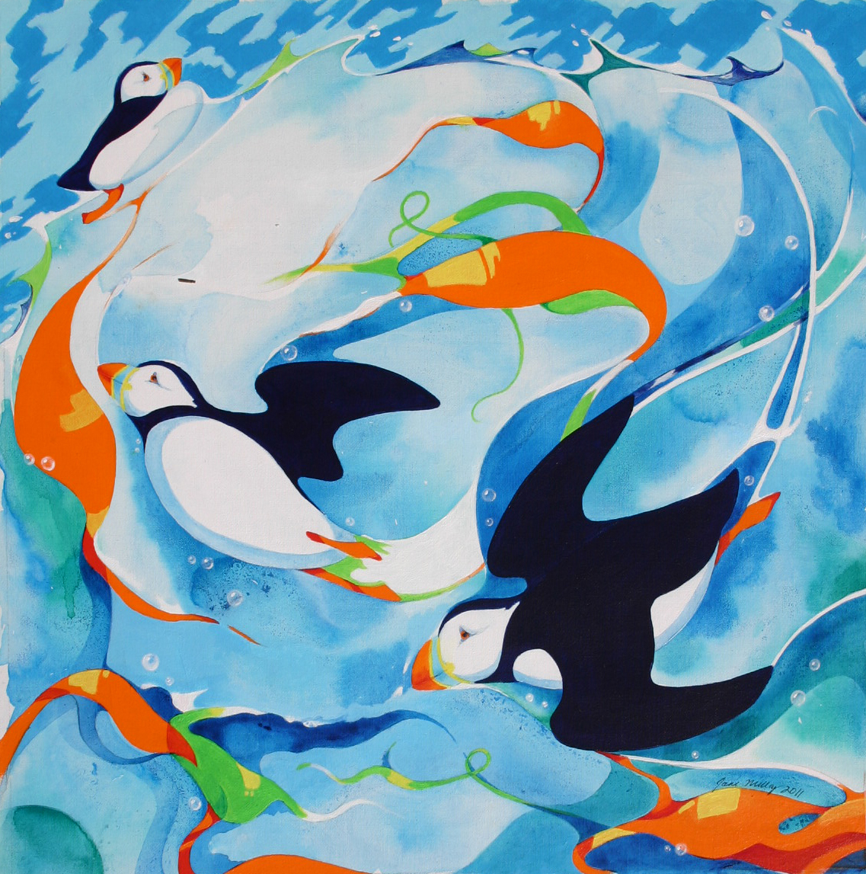 Jane Milloy in the Square Room, Logie Gallery

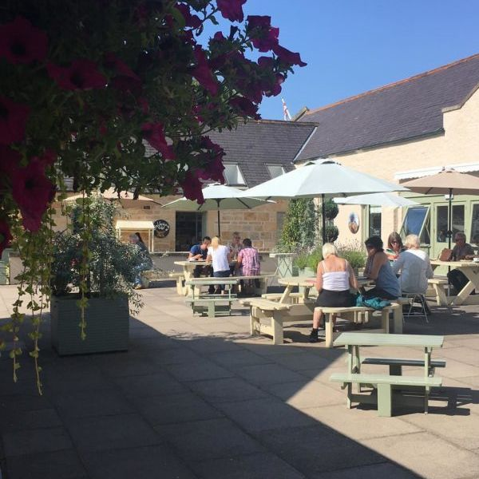 4 & 5 June: Jubilee BBQ at the Cafe

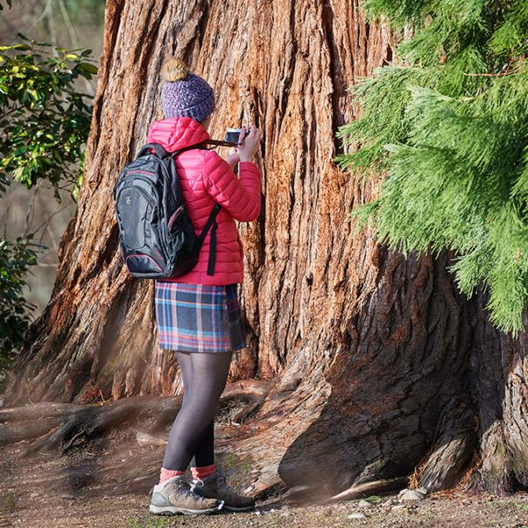 5 June Photography Walk with Gary Murison

Full details of all our events are on the Logie Steading What's On page

